1. **Create an app in salesforce simulating the functionalities of a Bank (App Label: “Bank”).**

**Steps:**

1. Setup → App Manager → **New Lightning App**.
2. App Name: **Bank**  
   Developer Name: Bank  
   Description: Banking app for branches, accounts, transactions, loans.
3. Branding: choose an icon/color.
4. Navigation Items: add tabs you’ll create (Bank, Branch, Account, Transaction, Loan, Loan Detail, Loan Payment).
5. Assign app to profiles or make visible to Admins for now.
6. Save & Finish

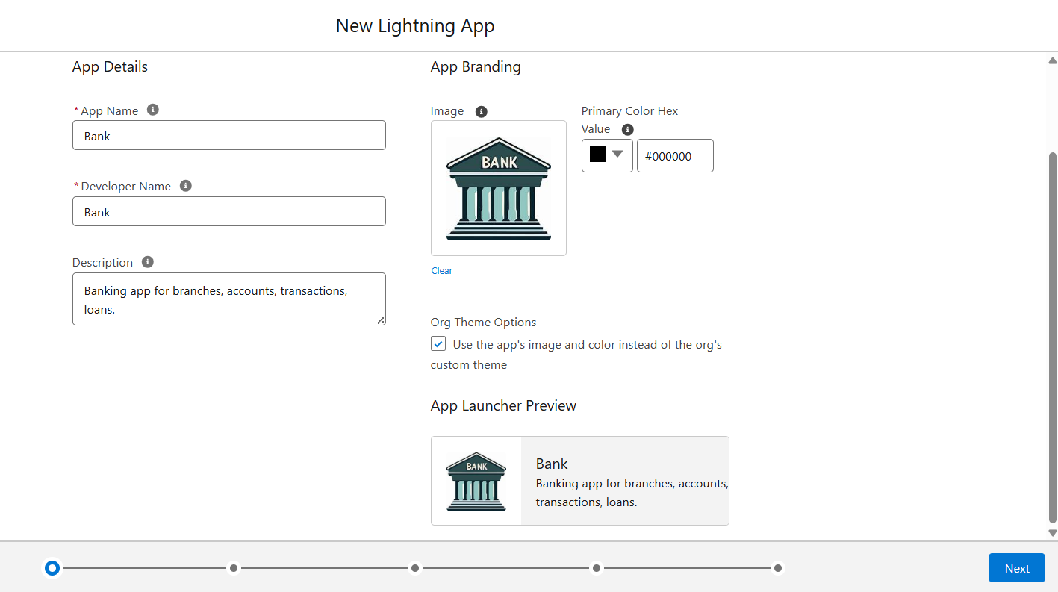

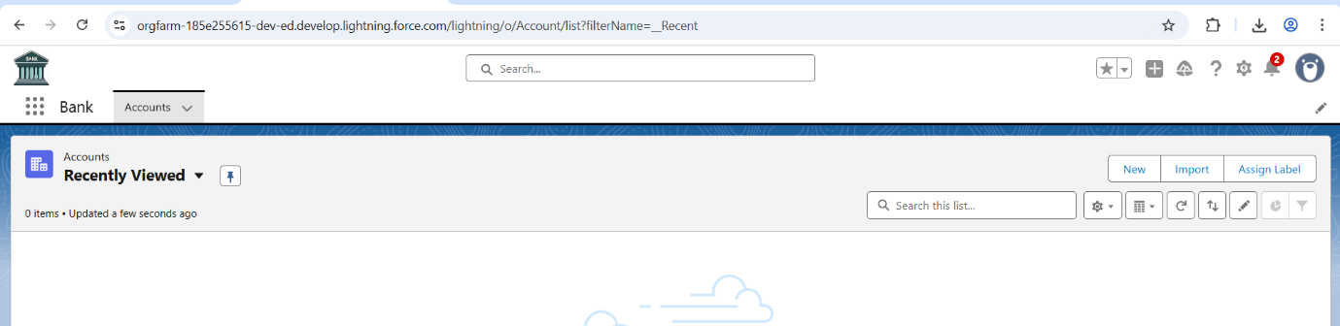

1. **It should have following tables to store data Bank, Branch, Account, Loan, Loan Detail and transaction.**

**Steps**

* In Salesforce, **“tables”** are called **Objects**.
* Each object stores data records, just like a database table.
* Create **Bank, Branch, Account, Loan, Loan detail** and **Transaction** Objects



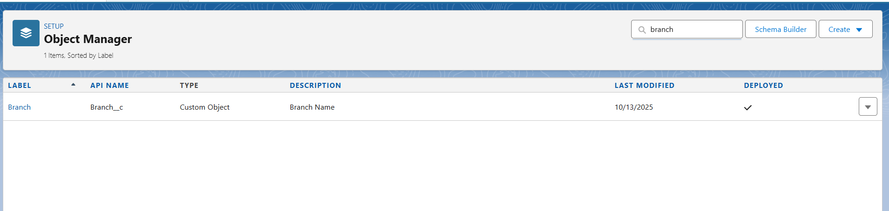

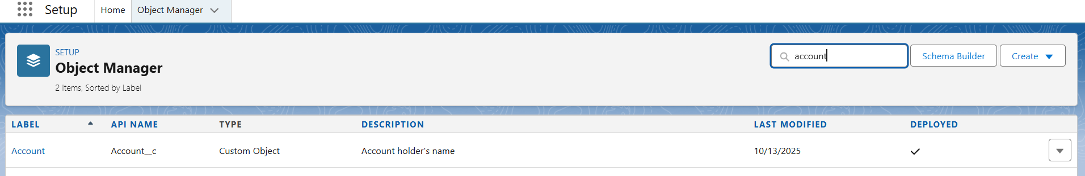

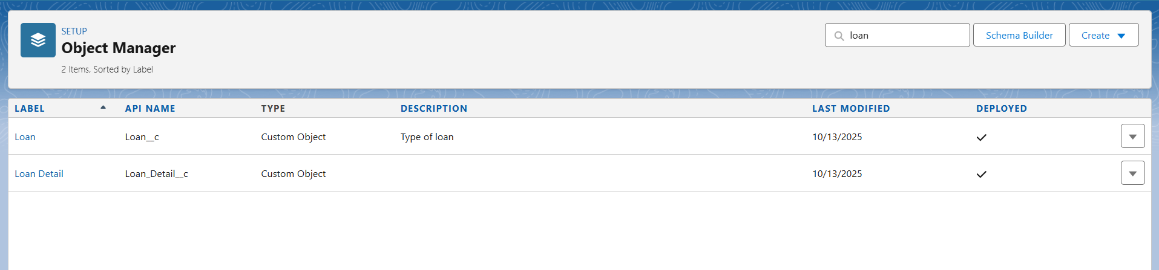



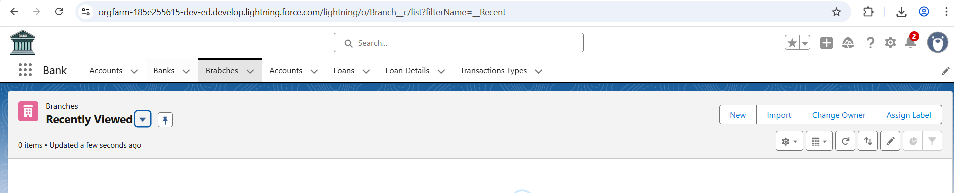

1. **A bank can have many branches and any branch cannot exist without a bank.**

**Meaning:**

* One **Bank** (like HDFC Bank) can have multiple **Branches** (like HDFC – Mumbai, HDFC – Delhi).
* But a **Branch** cannot exist independently — it must belong to one Bank.  
  i.e., you can’t have a Branch record in Salesforce without linking it to a Bank.

**⚙️ In Salesforce Terms**

* This type of dependency means:
* **Bank (Parent)** → **Branch (Child)**
* And since the **child cannot exist without the parent**,  
  the relationship type should be **Master–Detail Relationship**.

**Steps**

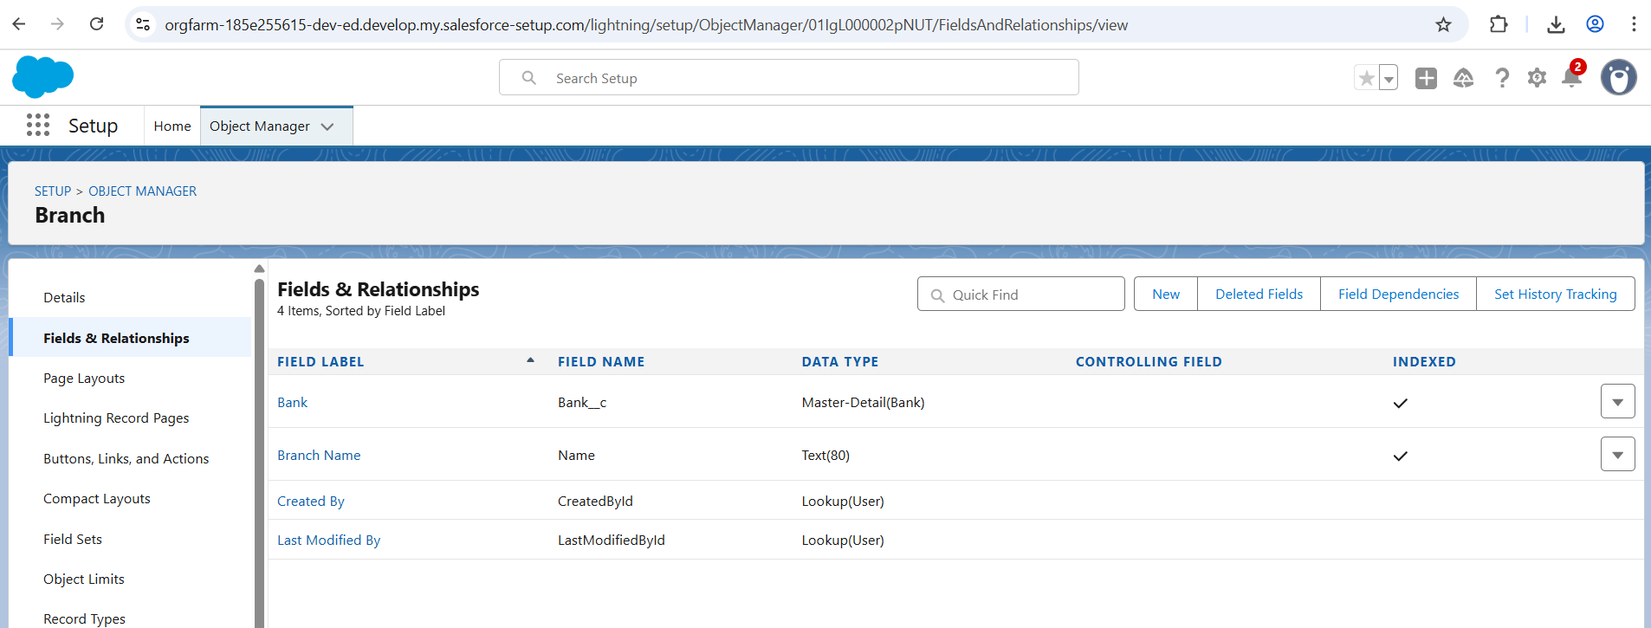

1. **A branch has many accounts and an account cannot exist without a branch.**

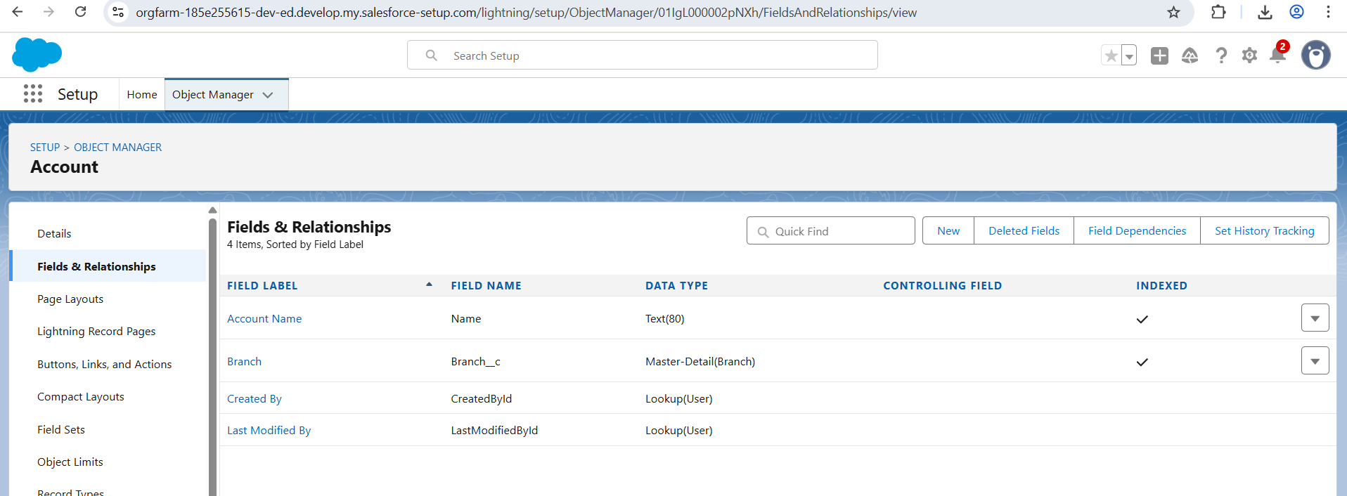

1. **An account can be shifted to any other Branch.**

**💡Meaning**

This means:

* Each **Account** belongs to a **Branch**,
* But that **Branch link is *changeable*** — meaning you can reassign an account from one branch to another.

**⚙️ Salesforce Interpretation**

In Salesforce, whether a child record (Account) can be **moved** from one parent (Branch) to another **depends on the type of relationship** used.

Master-Detail Relationship

**✅ Allowed:** Re-parenting (moving child to another master) **🧩 Requirement:** “Allow reparenting” must be enabled during relationship creation.

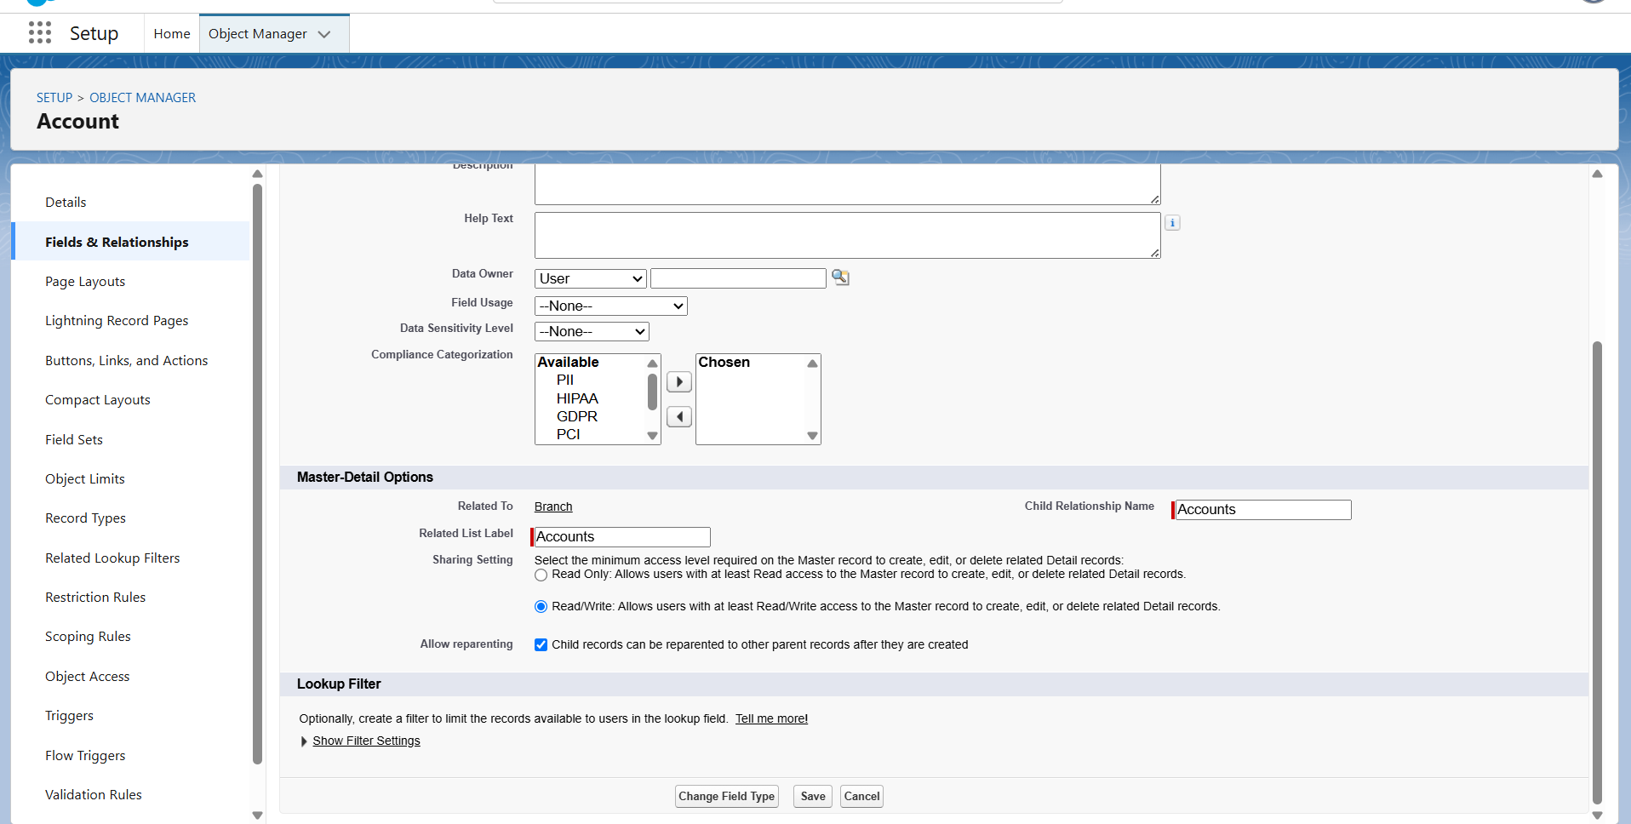

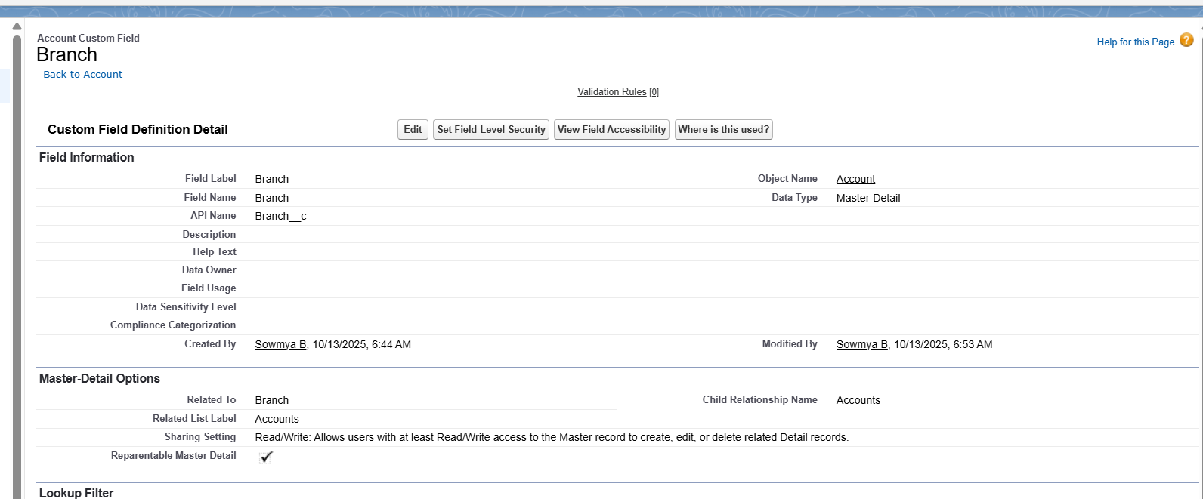

E Every account has transactions greater than or equal to 0. Transaction cannot exist without an

account.

Every account has transactions greater than or equal to 0. Transaction cannot exist without

Every